Discussion
Student’s Name
Institutional Affiliation

Question One: What would be an appropriate nursing response to this patient that is grounded in caring?
One of the appropriate nursing responses to this patient that is grounded in caring involves guidance and counseling. Guidance and counseling is a technique that nurses integrate when handling clients of varied characteristics. A nurse is required to express both sympathy and empathy when handling varied situations. Such expression enables nurses to be more caring to patients. Based on Peggy’s case, the nurse should establish a therapeutic relationship to address her needs. Counseling is important in this case because the nurse will advise Peggy on how to live healthy regardless of her traumatic experiences. The nurse should perform the role of the counselor to aid Peggy focus on a goal and establish techniques that enhance self-care. Through counseling, Peggy will understand that cancer is a condition that can be managed if detected early. This session will also enable her to accept her daughter’s death and avoid taking blame since this was a natural occurrence. Therefore, as a nurse, it is important to establish a closer relationship with the client as a way of hearing and addressing their multifaceted needs.
Question Two: How I currently use genetics or genetic testing in my nursing practice and whether I was familiar with these concepts prior to this lecture.
In the recent past, genetics and genetic testing have become of great importance in the nursing field. According to Hickey et al. (2018), genetics refers to the study of genes and their role in the disease's inheritance; In contrast, genetic testing is defined as a medical examination used in the identification of the changes that occurs in chromosomes, genes, or protein (Vajda et al., 2017). Throughout my nursing experience, genetics and genetic testing have played an essential role in clinical nursing practices, research, and education. In my nursing practice, I have applied genetics and genetic testing in different ways, such as understanding genetic disorders, making genetic disorders diagnoses, treating diseases, and predicting the effects of using medications to treat conditions.
Genetics has helped me to understand different genetic disorders. As per a study by Vajda et al. (2017), scientists have significantly embarked on identifying and explaining most of the genes present in human chromosomal components. Therefore, through this knowledge, it has become easy to learn about specific genetic disorders. For instance, scientists have grouped genetic diseases based on genetic abnormality. I have applied genetic testing to different diagnosis disorders such as Turner Syndrome and Down Syndrome. Also, through genetics, I have predicted the probability of patients developing certain genetic diseases. For example, in cases where women have the Breast Cancer gene, they are most likely to develop either ovarian cancer or breast cancer (Coleman, 2017). My predictions have enabled screening and prevention of the disease in women, thus improving the quality of life.
Additionally, through genetic tests, I have been able to make genetic disorder diagnoses before birth by assessing the presence of gene disorders before birth. If a pregnant woman is diagnosed with a congenital disease before delivery, treatment may be done after birth to prevent complications during pregnancy. However, nurses can give some drugs during pregnancy to reduce the impact of the genetic hormone on the unborn baby's (David, 2019). I have also applied genetics in the treatment of diseases like cancer. Through genetic knowledge, cancer patients are given anticancer drugs that aim at destroying specific cancer cells.
Moreover, genetic testing has helped me understand that some of the genetic information obtained from the test results might not be available in the family history. According to Hickey et al. (2018), when I present the results to the patient, I ensure effective communication to avoid misunderstandings. Therefore, through such scenarios, genetics plays a significant role in improving my practicing skills as I have to consider the cultural beliefs and attitudes towards genetics,
Furthermore, genetics has helped me to understand more about how the patient responds to specific drug therapies. As a nurse, it is fundamental to know the potential impacts of different medications on a patient's health. Through genetic knowledge, I can be able to predict how much medication does a specific gene needs. Taking too much drug may lead to complications while taking too low might be ineffective. Gene testing has also played a role in analyzing whether a patient will experience side effects of anticancer medications (David, 2019). Therefore, when administering medications, the patients who are likely to develop serious side effects towards certain drugs are treated with other medicines that do not have side effects.
Finally, a nurse needs to have basic knowledge of genetics. Before this lecture, I was familiar with genetics from the knowledge obtained in previous levels of studies. Also, I had learned more about genetics through online platforms that made me familiarize myself with different types of genetic disorders and how they present. Also, during the clinical practices, I handled different cases of genetic disorders, thus increasing my knowledge in genetics.

Question Three: My Three Generation Pedigree

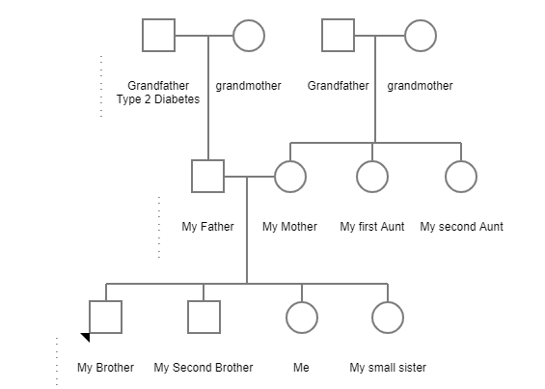
Based on the above pedigree, it is apparent that there is one case of a genetic red flag in our family's first generation. The presence of type 2 diabetes is a health issue of concern. It is still not known whether my grandfather acquired this condition genetically or whether it was generated environmentally. Fortunately, other members of the family in the subsequent generations do not experience this condition. I believe that we should make a move and conduct color genomic testing to identify the prevalence of such mutation in all members.

References
Coleman, C. (2017). Early detection and screening for breast cancer. Seminars in Oncology Nursing, 33(2), 141-155. https://doi.org/10.1016/j.soncn.2017.02.009
Hickey, K. T., Taylor, J. Y., Barr, T. L., Hauser, N. R., Jia, H., Riga, T. C., & Katapodi, M. (2018). Nursing genetics and genomics: The international society of nurses in genetics (ISONG) survey. Nurse Education Today, 63, 12-17. https://doi.org/10.1016/j.nedt.2018.01.002
Vajda, A., McLaughlin, R. L., Heverin, M., Thorpe, O., Abrahams, S., Al-Chalabi, A., & Hardiman, O. (2017). Genetic testing in ALS. Neurology, 88(10), 991-999. https://doi.org/10.1212/wnl.0000000000003686
Y David N. Finegold, (2019). Uses of genetics - Fundamentals - MSD manual consumer version. https://www.msdmanuals.com/en-jp/home/fundamentals/genetics/uses-of-genetics

